Linked List

V-1) Introduction:-

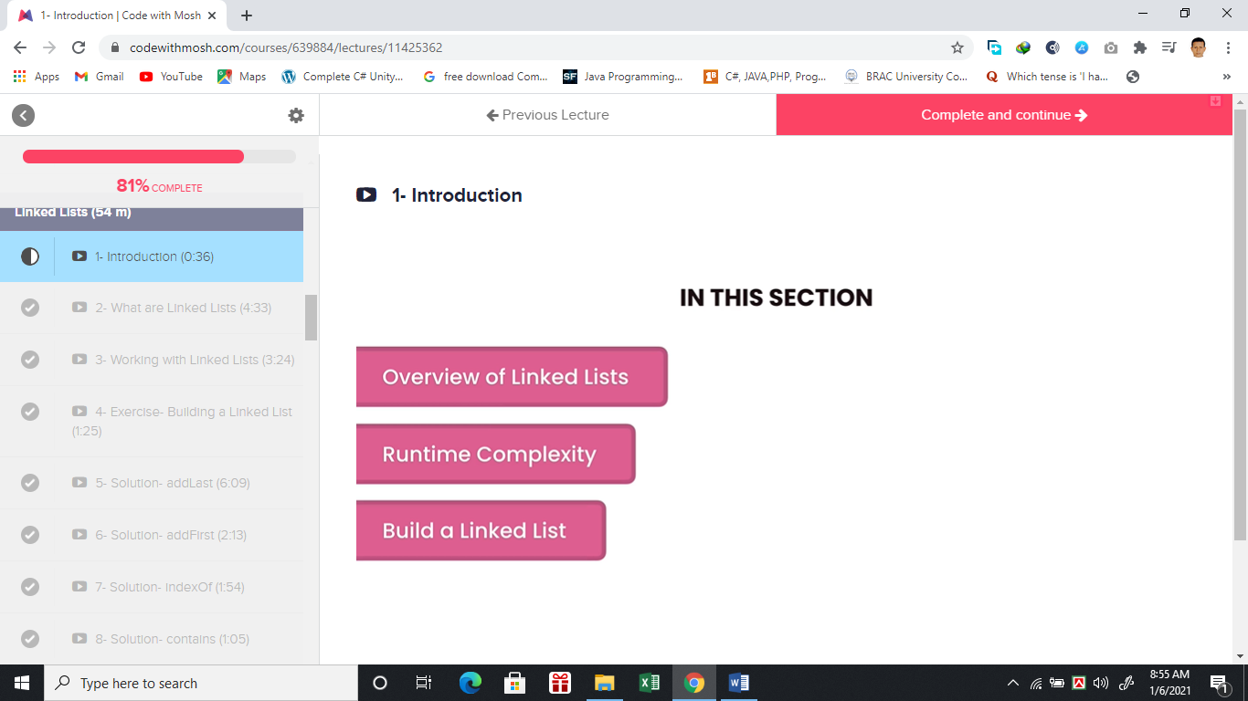

V-2) What Are Linked List?

**Tail**

Head

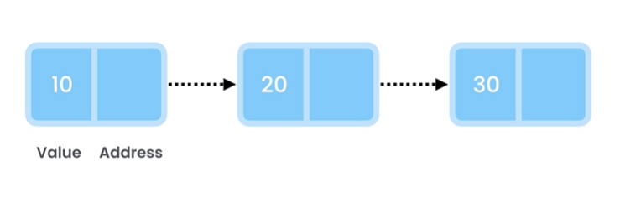

Here Data’s 10, 20, 30 are linked with one next to each. Where One Node has value and address of next node that’s goanna linked the two data’s. That’s why this structure of dataset is called Linked List. Above List is actually singly Linked List. There are total 8 types of linked lists.

Time Complexities:-

Scenario 1:-

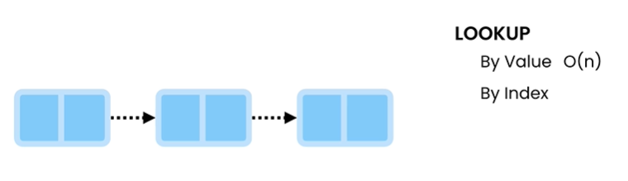

**O (n)**

For scenario 1 this linked list cannot direct access like indices of Array. Each node has a reference to a node. So at the worst case scenario for both value and index search might be at the end of the list. So , that’s why both cases has a complexity of O (n).

2. Insertion

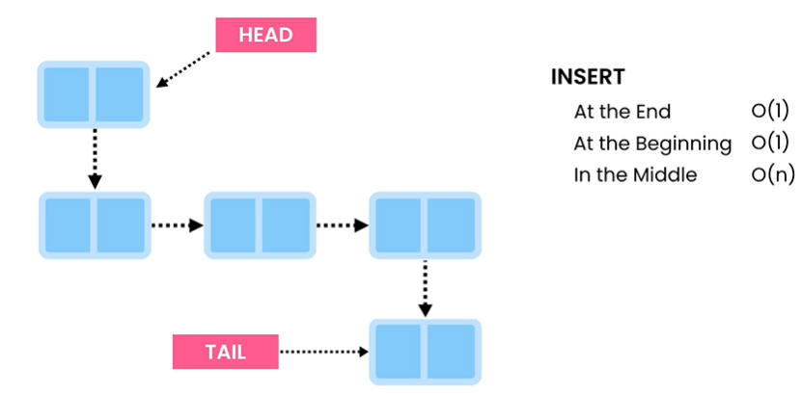

3. Deletion

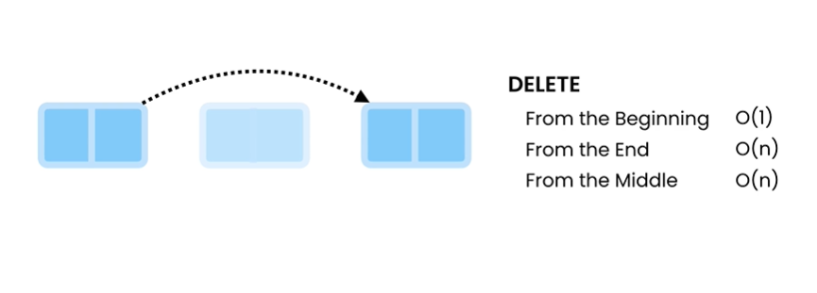

V- 3) Working with Linked_List

import java.util.Arrays;  
import java.util.LinkedList;  
  
public class Main {  
 public static void main(String[] args) {  
 // LinkedList <int> = new LinkedList<int>; //this will give error cause it is primitive we have to write the whole class  
 LinkedList list = new LinkedList(); // kisu nah khali create holo list  
 list.addLast(10);// [ 10 ]  
 list.add(20); // [ 10, 20 ]  
 list.addLast(10); // [ 10 , 20 , 10 ]  
 list.add(30);// [ 10 , 20 , 10 , 30 ]  
 list.addFirst(50); // [ 50 , 10 , 20 , 10 , 30 ]  
 System.*out*.println(list);  
 System.*out*.println(list.size()); // return size of the array means 5  
 System.*out*.println(list.indexOf(10));// find the first occurance of the given element which is 1  
 System.*out*.println(list.contains(10)); // return true if found the item in the list , false otherwise  
 var array = list.toArray();// eikhane variable er jaigai onno kisu dile kaj korbe nah  
 System.*out*.println(Arrays.*toString*(array)); // array ta list na niye print korlam  
 }  
  
}

V-(4-12)-working with LinkedList Descriptively:-

Global Variable in the LinkedList Class:-

private Node first;// reference of head  
private Node last;//reference of tail  
private int size;// reference of the list items exist in the list

Node class which is inside LinkedList class:-

private class Node {  
 private int value;//Node er value store korbe  
 private Node next;//Node er next element er reference rakbe  
 private Node(int value){  
 this.value = value;  
 }  
}

V-4. Add last Method (add new items at the end of the list)

public void addLast(int item){  
 // Node node = new Node(); eivabe likhe confused hoar dorkar nai  
 // kenona java compiler dan side dekhei buje nibe node kon type er object  
 //jodi var use kori  
 /*  
 var node = new Node();  
 node.value = item;  
 */  
 var node = new Node(item);  
 if(isEmpty())// jodi list empty thake tahole List er first & last node eki  
 first=last=node;  
 else{  
 last.next = node;//existing last node er pore ei notun node boslo  
 last = node;//last variable jeta node er tail reference kore seta update korlam  
 }  
 size++;  
}

main class:-

public class Main2 {  
 public static void main(String[] args) {  
 var list = new LinkedList();  
 list.addLast(10);  
 list.addLast(20);  
 list.addLast(30);  
 }  
}

V-5-(addFirst method with listempty checking):-

public void addFirst(int item){  
 var node = new Node(item);  
 if(isEmpty())  
 first=last=node; //jodi list empty thake  
 else {  
 node.next = first;// first e notun node er sathe first ke link  
 first = node;// then update the first cause head of the list changes  
 }  
 size++;  
}

V-6 –(indexof method)

public boolean contains(int item){// ei method e amra indexof method ke reuse korlam  
 return indexOf(item)!=-1;// eikhane item khuje paile true return korbe otherwise false return korbe  
// indexOf method integer return kore  
// se jodi uporer contains method er call e -1 return na kore mane list e  
// oi item ta ase taile contains method true return korbe  
// ar -1 return korle mane item ta list ei nai tai contains method  
// false return korbe   
}

V-7-(RemoveFirst Method[little complicated])

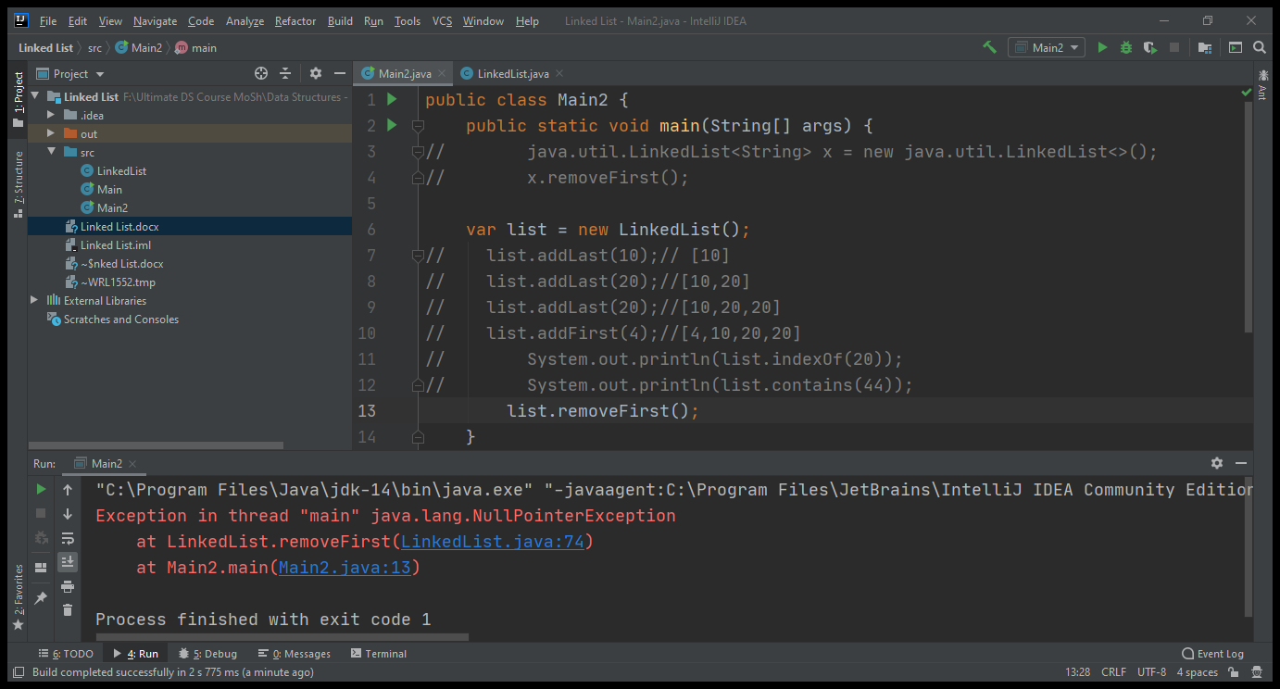

As the list is empty so we got null pointer exception.

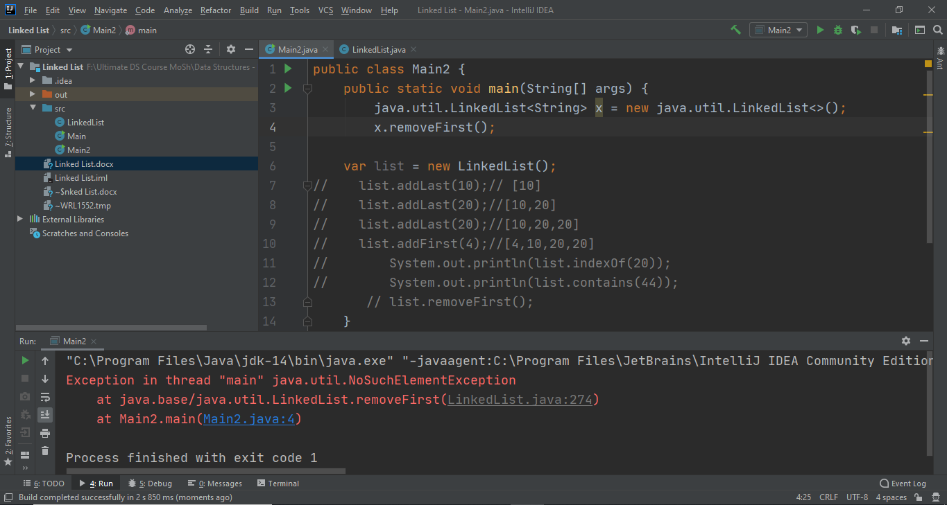

In java linkedlist built in class we got NoSuchElementException instead of Nullpointer exception. So, we need to implement our code in the way its built in java packages.

[Built in java linkedlist removeFirst() call:-

java.util.LinkedList<String> x = new java.util.LinkedList<>();  
x.removeFirst();

]

So, our final modified method for removefirst is:-

public void removeFirst(){  
 if(isEmpty()) throw new NoSuchElementException();  
 if(first==last) //list e jodi ekta element thake  
 first = last = null;  
 else{  
 /*  
 ekon amar onek sabdhane korte hobe remove  
 ex [10->20->30]  
 ami chailei 20 take first banai diye first.next null  
 korte parbo nah ete pura list harai jabe  
 */  
 var second = first.next;//ex [10->20->30] eikhane 20 er reference save raklam  
 first = null;// 10 er sathe 20 er bonding remove korlam  
 first = second;// ekon first ke 20 e point korlam ekon list hobe [20->30]  
 }  
 size--;  
}

V-8-(RemoveLast() method)-[complex]

public void removeLast(){  
 // list jodi empty hoi tahole remove korar kisui thakbe nah sekehetre exception dekhabo  
 if(isEmpty())  
 throw new NoSuchElementException();  
 //list e only ekta element thakle jevabe remove korbo  
 if(first==last)  
 first=last=null;  
 else {  
 // [10,20,30]  
 // the logic below written is only working for list with atleast two node  
 var previous = getPrevious(last); // previous = 20  
 last = previous; // last ekon 30 theke 20 ke point korlo  
 last.next = null;// 20 er sathe 30 er bondhon chinno kore dilam (garbage collector)  
 }  
 size--;  
}

V-9-(Implementing Size)

public int size(){  
 return size;  
}

V-9-(Cheat Sheet Gone Wrong If we memorize specially for Job Interview)

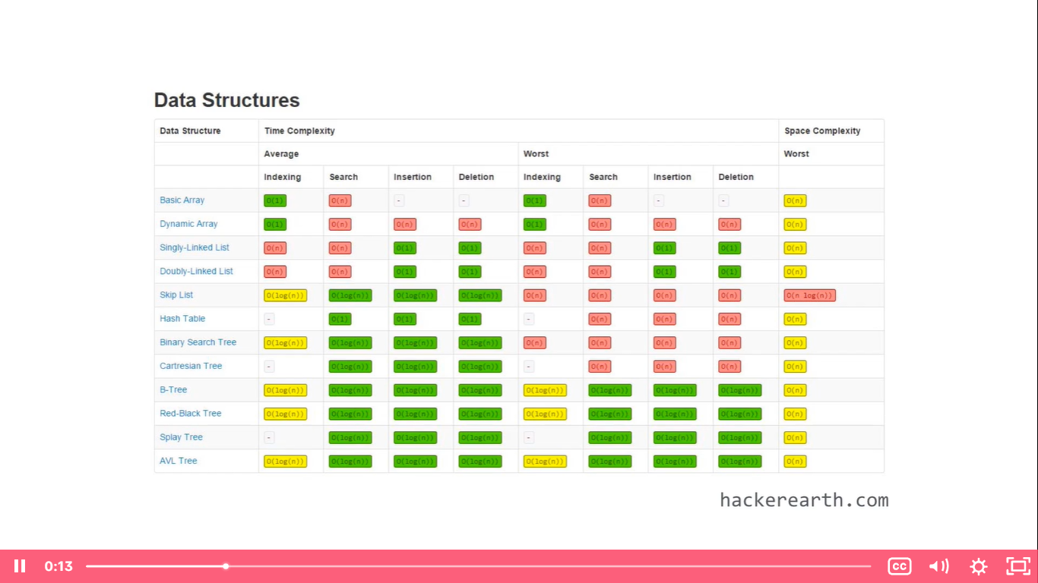

V-10-(Array & LinkedList Comparison)

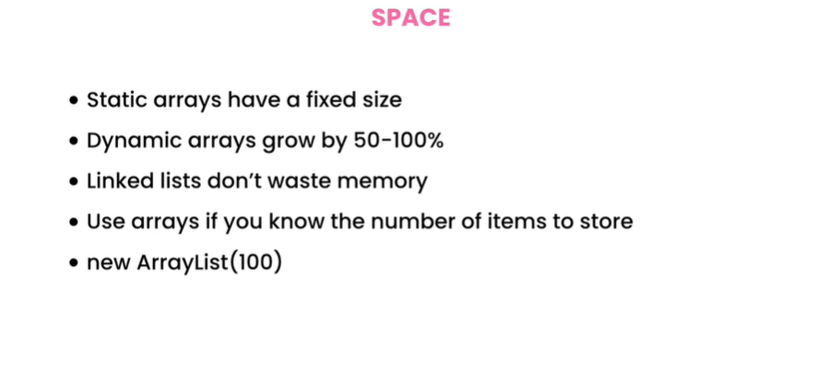

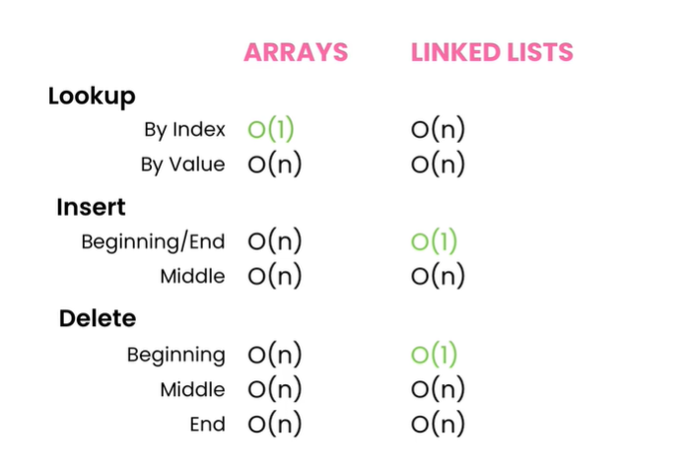

**For traversing the whole list**

**For traversing the whole list**

**For Shifting elements**

**For Shifting**

**elements**

**(Singly List Only)**

V-15-(Types of Linked List)

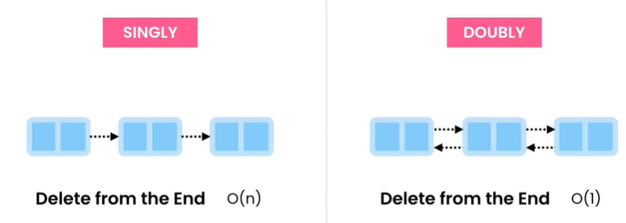

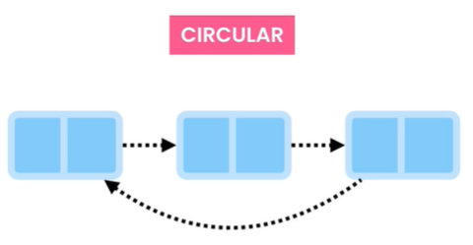

Circular Linked List needed when we build something called music player . Cause at the end of the playlist it needs to start from the beginning .



public void reverseList(){  
 //List ta inplace reverse korte hobe  
 //[10->20->30]  
 //hote hobe [30->20->10]  
 //onek somossa  
 // 10-> 20-> 30  
 // p c n  
 // n = c.next diye reference rakbo  
 // link change korbo ekon c.next = p;  
 if(isEmpty()) return;  
 var previous = first;// p  
 var current = first.next;// c  
 while (current!=null){  
 var next = current.next;// n  
 current.next = previous;// link er direction change  
 previous = current;  
 current = next;  
 }  
 last = first;  
 last.next = null;  
 first = previous;  
}

EX-2) Find kth node from the end. –[Popular interview question about SLL]

If List Has 10-> 20->30->40->50

And if we pass the value 3 for k it should return 30. It should be solved through 1 call . That means we can’t iterate through the whole list.

Ans:- We can solve this problem using 2 pointers.

*The idea is that when the 2nd pointer reached the end of the list it should find the expected value as in the 1st pointer. So, pointer should be selected properly and also handle the exceptions.*

**P1**

**P2**

**10-> 20 ->30 ->40 ->50**

**P2**

**P1**

**10-> 20 ->30 ->40 ->50**

Lets solve this:- [very much complicated]

public int getKthfromtheEnd(int k){  
 if(isEmpty()) throw new IllegalStateException();  
 //setting two pointers  
 // 10 -> 20 -> 30 -> 40-> 50  
 // a  
 // b  
 // if k = 3  
 var a = first;  
 var b = first;  
 //for loop simulation  
 // 10 -> 20 -> 30 -> 40-> 50  
 // a  
 // b  
 // 10 -> 20 -> 30 -> 40-> 50  
 // a  
 // b  
 for(int i=0;i<k-1;i++){// this loop will set the distance between two pointers  
 b= b.next;  
 if(b==null) throw new IllegalArgumentException();  
 }  
 // while loop simulation  
 // 10 -> 20 -> 30 -> 40-> 50  
 // a  
 // b  
 // 10 -> 20 -> 30 -> 40-> 50  
 // a  
 // b  
 while (b!=last){  
 a=a.next;  
 b=b.next;  
 }  
 return a.value;  
}

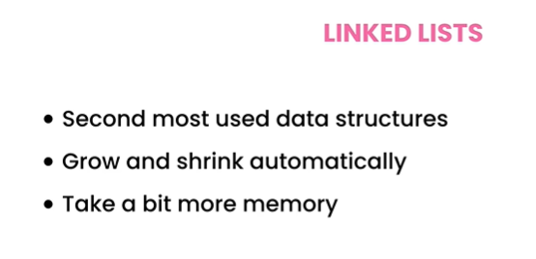

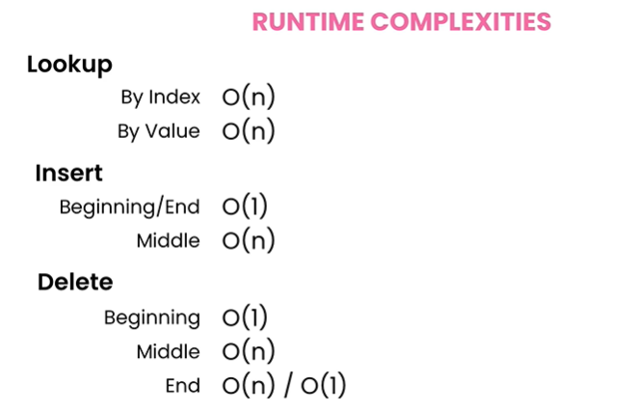

Ex-3-exclusive) **Find the middle of a linked list in one pass.-**

public void printMiddle() {  
 if (isEmpty())  
 throw new IllegalStateException();  
 var a = first;  
 var b = first;  
 while (b != last && b.next != last) {  
 b = b.next.next;  
 a = a.next;  
 }  
 if (b == last)  
 System.*out*.println(a.value);  
 else  
 System.*out*.println(a.value + ", " + a.next.value);  
 }

Ex-4) if There is any loop or not in a SLL?

public boolean hasLoop() {  
 var slow = first;  
 var fast = first;  
 while (fast != null && fast.next != null) {  
 slow = slow.next;  
 fast = fast.next.next;  
 if (slow == fast)  
 return true;  
 }  
 return false;  
}

Exercise 3 and 4 explanation is given below:-